**Exit The Plugin**

**A MINI-PROJECT REPORT**

# Submitted by

**Group/Team No: G22/12**

**Divyan Rai, Rollno: 2210990295**

**Divyanjali Singla, Rollno: 2210990296**

**Divyanoor Singh Saini, Rollno: 2210990297**

**Divyansh, Rollno: 2210990298**

***in partial fulfillment for the award of the***

# degree of

**BACHELOR OF ENGINEERING**

***in***

COMPUTER SCIENCE & ENGINEERING



**CHITKARA UNIVERSITY**

**CHANDIGARH-PATIALA NATIONAL HIGHWAY**

**RAJPURA (PATIALA) PUNJAB-140401 (INDIA)**

(**May,2023**)

TABLE OF CONTENT

|  |  |
| --- | --- |
| 1 | Introduction |
| 2 | Problem statement |
| 3 | Technical details |
| 4 | Key advantages |
| 5 | Project advantages |
| 6 | Result |
| 7 | Conclusion with future scope |

**1. Introduction:**

An exit plugin, also known as an exit-intent popup or exit overlay, is a tool used to retain website visitors who are about to leave a webpage. It's a popup window that appears on the screen when the visitor is about to leave the page by clicking on the "X" button, closing the tab or clicking on the back button.

The purpose of an exit plugin is to offer visitors a special offer, discount, or valuable information that will make them reconsider leaving the page. The exit popup can be customized to match the website's design and can contain various elements like images, videos, forms, or text.

Exit plugins can be used to achieve a variety of goals, such as increasing sales, collecting emails, reducing bounce rate, or improving user engagement. It's a powerful marketing tool that can help website owners to keep their visitors engaged and turn them into customers**.**

In this project we make a replica of the exit the plugin with the help oh the **HTML & CSS.** In this we make only a **Frontend** of the exit the plugin, where we get an popup of Minerva defence academy advertisement after clicking on sign in button and exit it by clicking on ok.

**2. Problem Statement:**

The problem statement of exit plugins is how to use them effectively without interrupting the user experience or causing annoyance to website visitors.

Another challenge is creating a compelling offer or message that will entice visitors to stay on the page. The exit plugin should provide value and be relevant to the visitor's interests or needs, or they may simply ignore it and proceed to leave the page.

Furthermore, exit plugins can negatively impact the website's performance if they are not optimized for speed and mobile devices. Slow-loading or non-responsive popups can cause frustration and lead to a poor user experience.

Overall, the problem statement of exit plugins is to find a balance between using them effectively to achieve business goals while still providing a positive user experience that encourages visitors to return to the website in the future.

**3.Technical Details:**

Document type declaration: In our HTML file, we have included a document type declaration at the beginning. You can mention this in your file as well. For example, <!DOCTYPE html>.

HTML and CSS: To create the front-end of our popup page and search engine behind it look alike we used html and css.

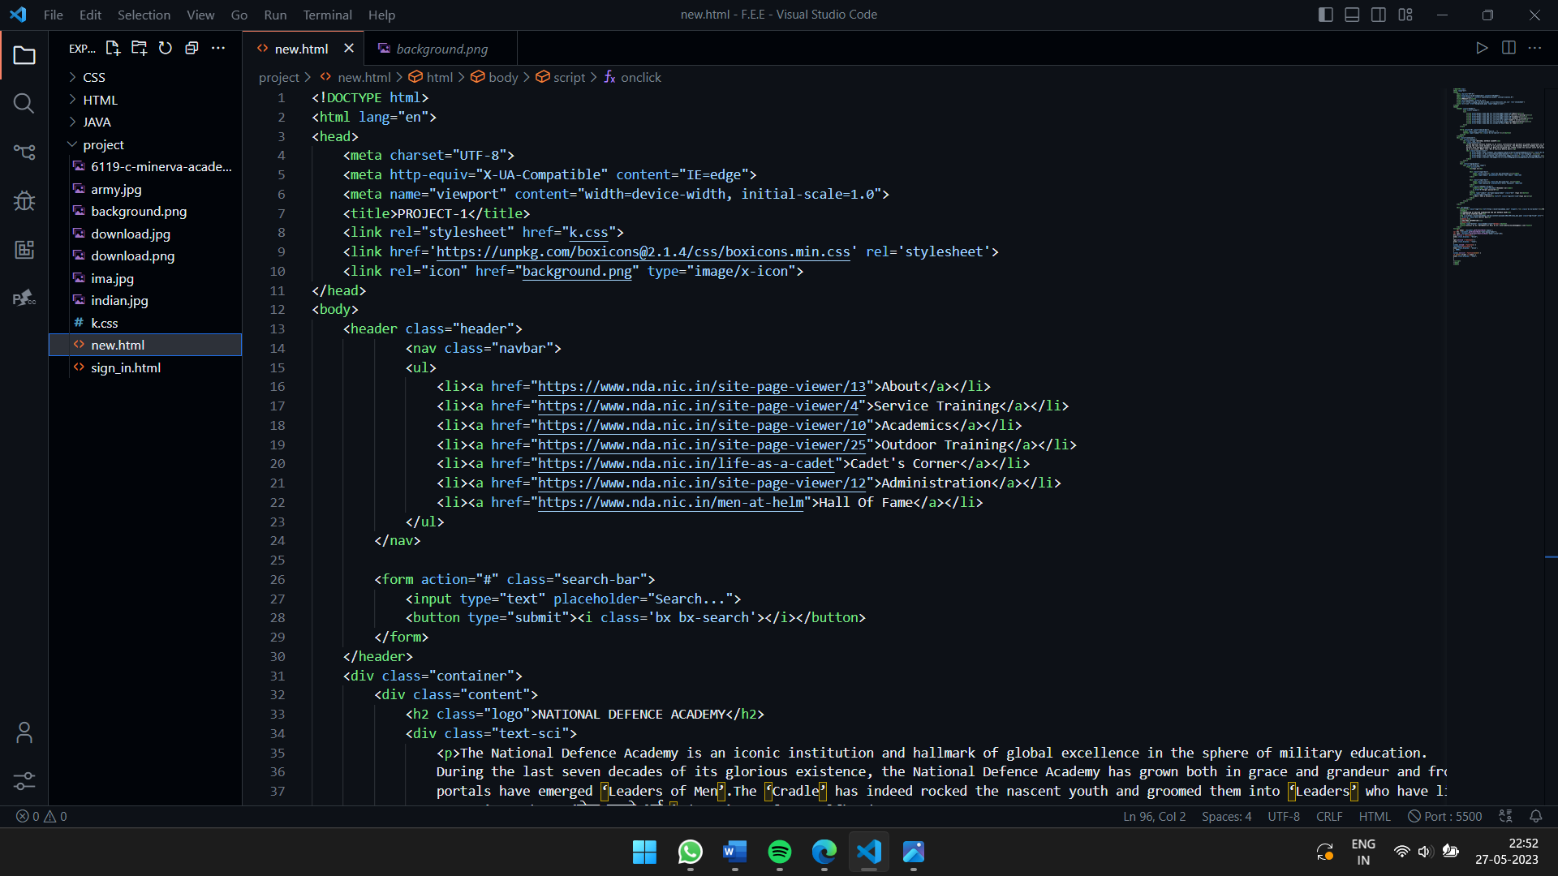This is an HTML code that defines the structure and content of a webpage.

The first line of code (``) declares the language of the document to be English.

The `<head>` section contains meta tags and links to external resources that the page requires. In this code, there are four meta tags: `charset`, `http-equiv`, `viewport`, and `title`. The `charset` tag specifies the character encoding used in the document (UTF-8, in this case). The `http-equiv` tag provides information about how the browser should handle certain features, such as compatibility mode. The `viewport` tag sets the width of the viewport to match the device's screen width, and the `title` tag sets the title of the page that appears in the browser's tab. Additionally, there is one link to external resource, i.e., to the Boxicons.

The ‘<body>’ section contains visible content of the page. In this code, there is a ‘<style>’ tag that defines style rule for ‘<span>’ elements. The rest of the content is wrapped in a ‘<nav>’ element with class of ‘header’. The search bar content is wrapped in ‘<form>’ element within class of ‘header’. The <div class=”container”> starts a container area where further work is done. The <a> tags with title attributes of “linkedin”, “telegram”, “Instagram”, “twitter” and href attributes of <https://www.linnkedin.com/company/indian-army/>, <https://t.me/s/joinindianarmy/>, <https://www.instagram.com/indianarmy.adgpi/>, <https://twitter.com/adgpi/>, create links to these websites with corresponding titles.

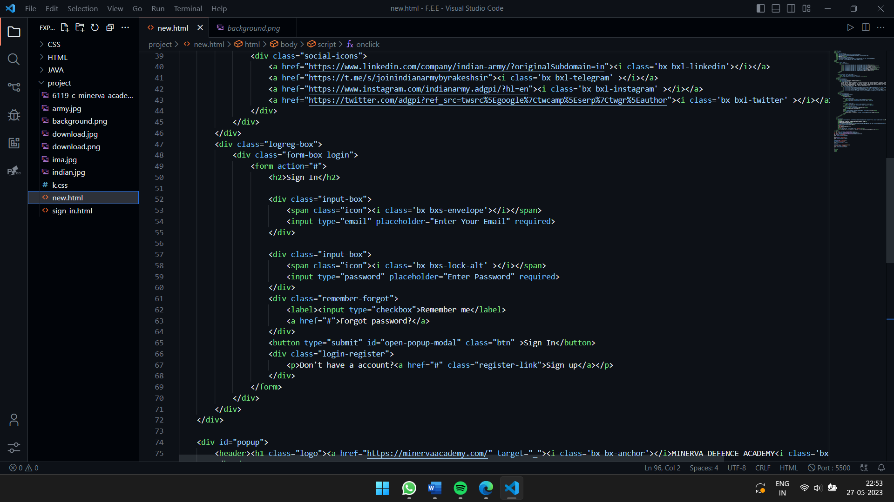The ‘<div>’ attribute with class= “logreg-box” is used to make area where we will make a form. Under this, there is a class= “form-box login” which is used to make login section of the form. Under this, there is class= “input-box” where details would be input. In this, there is <span> attribute with <i> attribute with class= ‘bx bxs-envelope’ and class= “bx bxs-lock-alt” which shows the email and lock icon respectively. There is ‘<div>’ attribute with class= “remember-forgot”, under which there is input attribute with type= “checkbox” which shows a checkbox written with “Remember Me”. After this, there is button attribute with id=‘open-popup-modal’ with class=‘btn’ which shows link with Sign In written.

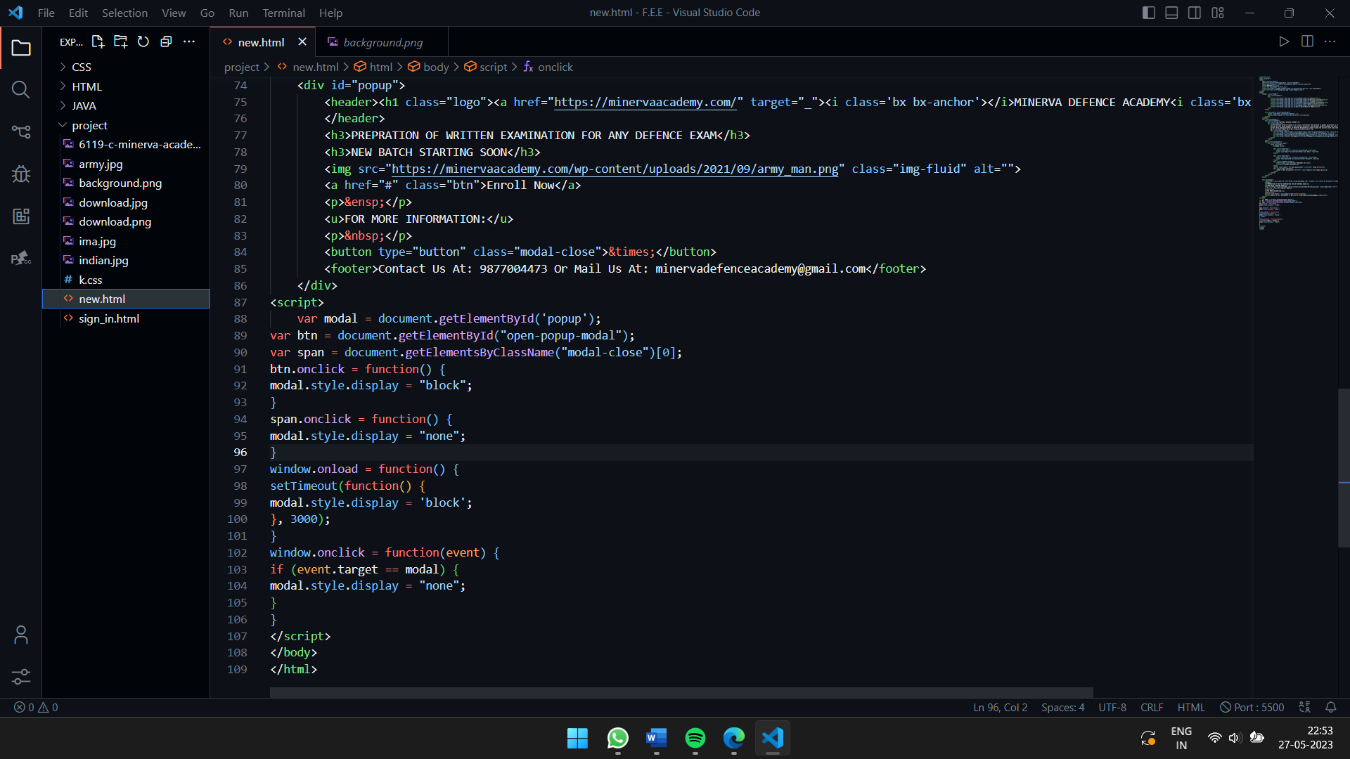The <div> attribute with id=‘popup’, under which there is <h1> attribute with class=‘logo’, in which there is <a> attribute with href link to external website <https://minervaacademy.com/>. There is <img> attribute which contains the src link to the image of the academy. The <button> attribute with type= ‘button’ and class= ‘modal-close’ shows a cross icon at the top right portion of the popup. There is <footer> attribute in which there is the mode of contact written.

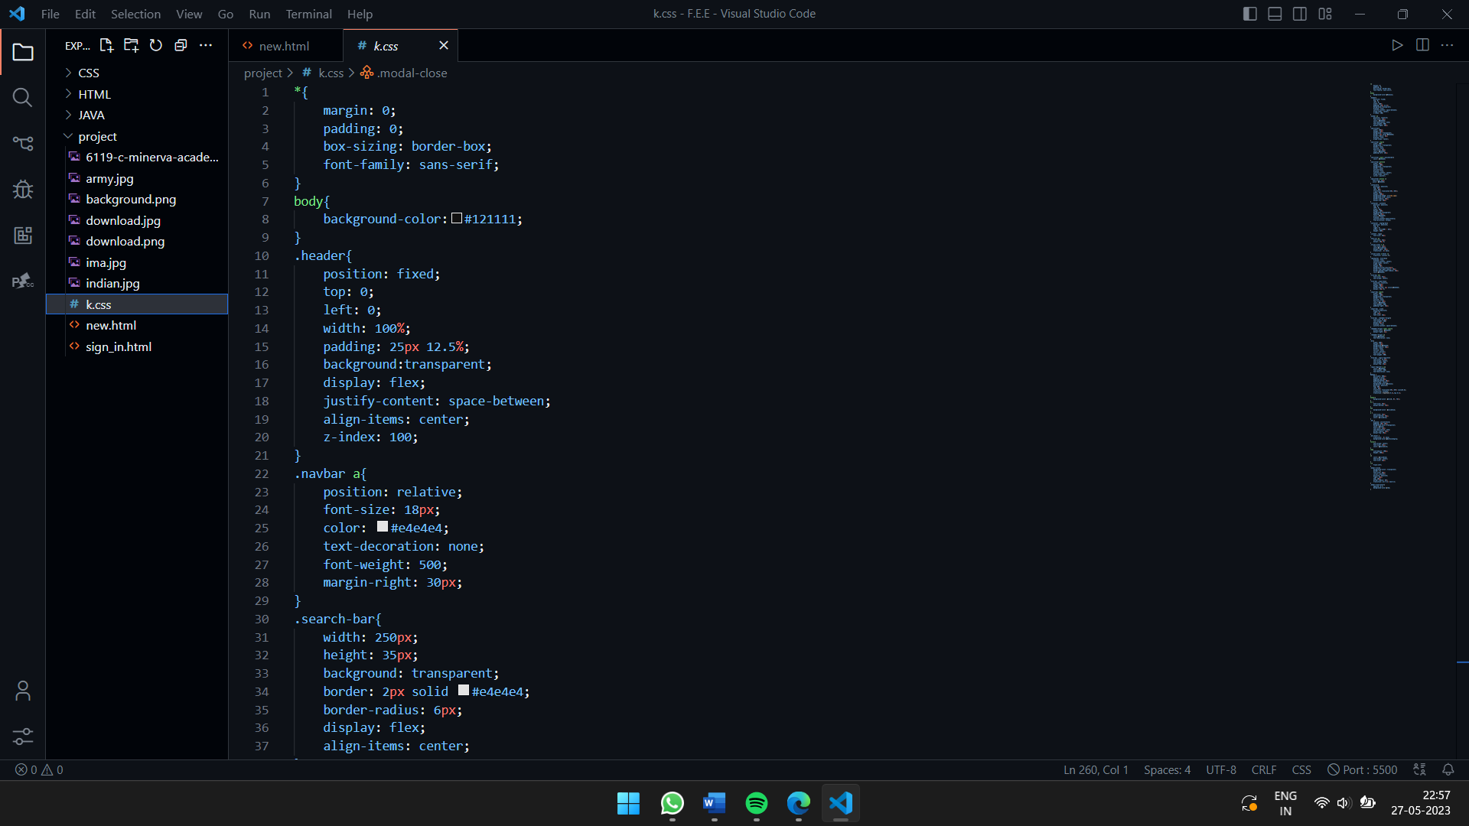This is a CSS code that styles the HTML elements of a webpage. Here’s a breakdown of some of the sections: -‘*{margin:0; padding:0; box-sizing:border-box; font-family:sans-serif;}: margin is used to sets the margin of all elements to 0, removing any default spacing between elements. we also adds padding to the top and bottom of the container.in this we also add box-sizing: border-box which specified width and height properties include the padding and border dimensions, and the content area is adjusted accordingly.we also applied sans-serif using font-family tag which are the small decorative strokes at the ends of characters. Sans-serif fonts are often considered more modern and straightforward compared to serif fonts.

Body{background-color:#121111;} : by using background-color ,we set the background of the main page to black where #121111 is the code of that color.

.header{position: fixed; top: 0; left: 0; width: 100%;padding: 25px 12.5%;background:transparent;

display: flex; justify-content: space-between; align-items: center z-index: 100;} : in this we set it position at fixed .so, it remains in the same position even when the user scrolls the web page.we set it top and left at 0 and width , padding at 100% and 25px 12.5 % . we set its back grount colour to transparent.

.navbar a{position: relative; font-size: 16px;color: #e4e4e4; text-decoration: none;font-weight: 500;margin-right: 30px;} : we set it position to relative means an element relative to its normal position in the document flow. When an element has a relative position, it can be shifted or moved from its original position, but the surrounding element are not affected. The font-size property in CSS is used to specify the size of the text content within an element. It determines the visual size of the font used to display the text and we set it at 16 px . we set it color to white having code #e4e4e4 and text decoration to none ( which means it removes the default text decorations that are typically applied to hyperlinks by browsers.).we take it font size and margin right 500 and 30 px.

.search-bar{width: 250px; height: 35px;background: transparent;border: 2px solid #e4e4e4;border-radius: 6px;display: flex;align-items: center; } : In this we use width , height and background and set it to 250px,35px and background color at transparent . we take border and border radius to 2px and 6px . we also use display:flex which set the display to flex and centers the elements vertically using align-items.

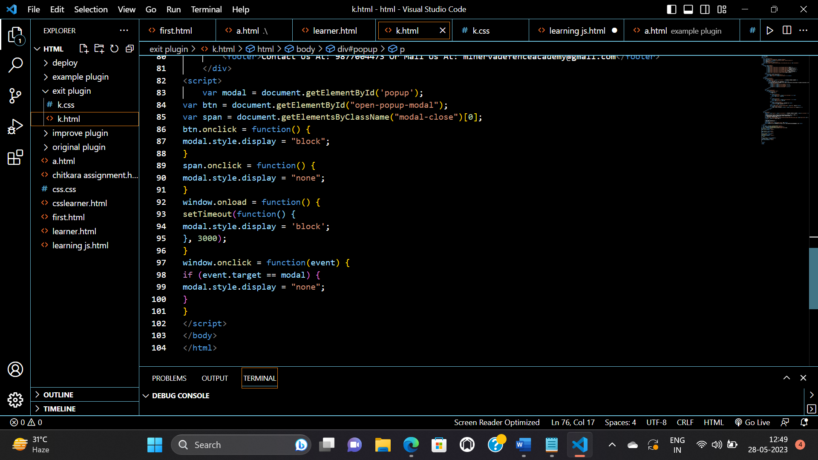this is an javascript code , It enables interactive and dynamic functionality on websites, allowing developers to create more engaging and interactive user experiences. Let’s go through the code step by step:

The **‘modal’** variable is assigned the DOM element with the id 'popup'. This element represents the modal popup .The **‘btn’** variable is assigned the DOM element with the id 'open-popup-modal’. this element is the trigger/button that opens the modal. The **‘span’** variable is assigned the first element with the class 'modal-close'. This element represents the close button within the modal.This code assigns a click event handler to the **‘btn’** element. When the button is clicked, the function is executed, and it sets the **‘display’** style property of the **‘modal’** element to "block", making the ‘modal’ visible.

This code assigns a click event handler to the **‘span’** element (close button). When the close button is clicked, the function is executed, and it sets the ‘**display’** style property of the ‘**modal’** element to "none", hiding the modal.This code sets a timeout function that executes after the page loads. After a delay of 3000 milliseconds (3 seconds), the function sets the **‘display’** style property of the **‘modal’** element to "block", making the modal visible automatically after the specified delay.This code assigns a click event handler to the window object. When a click event occurs anywhere on the window, the function is executed. If the clicked element is the **‘modal’** element itself, the **‘display’** style property is set to "none", hiding the modal.

**4. Key Features:** Customizable Design: An exit plugin should allow website owners to customize the design and layout of the popup window to match the branding and design of their website. This can include adding images, colors,fonts,andlogos. TargetedMessaging: The exit plugin should provide targeted messaging that's relevant to the user's interests or needs. This can be achieved by segmenting the audience and displaying different messages based on their behavior or preferences.

Compelling Offer: The exit plugin should offer a compelling incentive that encourages users to stay on the website. This can include special discounts, free trials, exclusive content, or other valuable offers.

Analytics and Reporting: The exit plugin should provide analytics and reporting that allows website owners to track the performance of the popup window and measure its impact on website metrics like conversion rates and bounce rates.

**5. Project Advantages:**

Increased Conversions: An exit plugin can help increase conversions by providing a last-ditch effort to persuade users to take a desired action before leaving the website. This can include subscribing to a newsletter, completing a purchase, or filling out a form.

Improved User Experience: When implemented correctly, an exit plugin can enhance the user experience by providing targeted messaging that's relevant to the user's interests or needs. This can help build trust and credibility with the user, leading to a positive perception of the website and brand.

Personalized Marketing: An exit plugin can provide website owners with the ability to create a personalized marketing experience for their users that encourages them to take a specific action. This can include targeting different messages or offers to different segments of the audience based on their behavior or preferences.

A/B Testing: The ability to A/B test different versions of the exit plugin can help website owners identify the most effective design, messaging, and timing for the popup window, leading to improved conversion rates.

Cost-Effective: Compared to other forms of marketing, such as paid advertising or email marketing, implementing an exit plugin can be a cost-effective way to improve website conversions.

**6 .Result :**

**Without popup**:

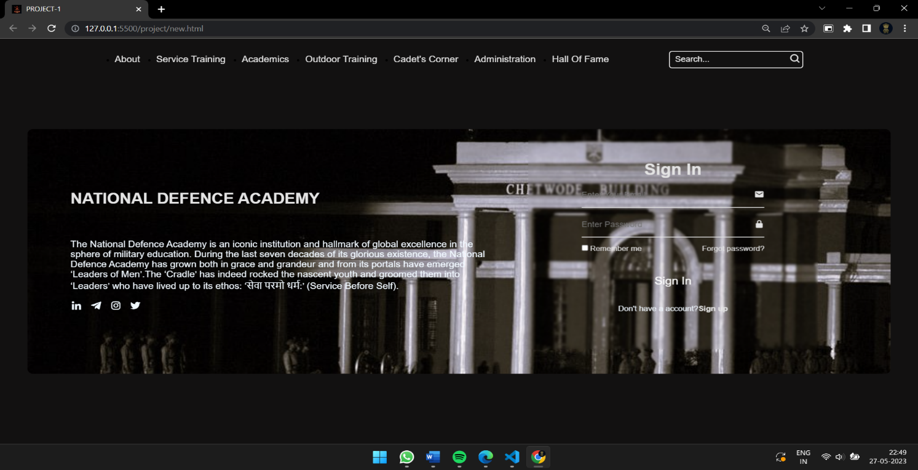

**With popup:** 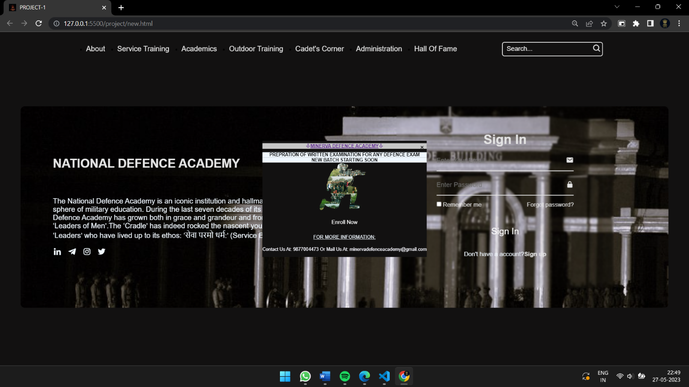

**7.Conclusion :**

In conclusion, an exit plugin can be a powerful tool for website owners to improve their conversion rates, reduce bounce rates, and enhance the user experience. By providing targeted, personalized messaging to users who are about to leave the website, an exit plugin can help persuade them to take a desired action and stay on the website longer.

Additionally, with the increasing popularity of mobile devices, we can expect to see a greater emphasis on mobile optimization for exit plugins to ensure a seamless user experience across all devices.

**8.Future Scope:**

In the future, we can expect to see further advancements in exit plugin technology, including more sophisticated targeting capabilities, improved design customization options, and enhanced analytics and reporting. As website owners continue to focus on providing personalized and engaging experiences for their users, the role of the exit plugin in achieving these goals will likely become even more important.

Moving forward, there is plenty of potential for this project to be improved and expanded upon. Overall, the future of exit plugins looks promising, and website owners who prioritize implementing this technology will likely see a significant impact on their website performance and conversions.

|  |
| --- |
|  |

**\*\*\*\*\*\*\*\*\*\*\*\*\*\*\*\*\*\*\***

13